Knowledge Brief

Health, Nutrition and Population Global Practice

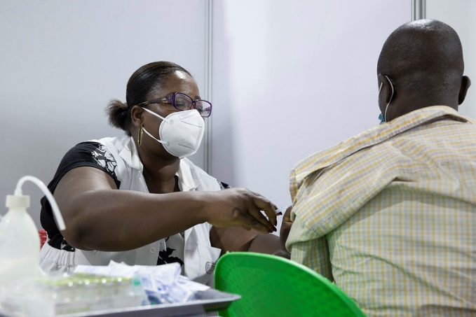

Engaging the private sector for the national COVID-19 vaccine rollout

October 2021

- Very few (if any) countries will be able to organize a vaccination campaign covering the entire population, with public resources alone. Partnering with private sector actors is the obvious choice to increase speed and scale.
- While some countries have experience in collaborating with private actors, others are less prepared and are starting from a position of limited mutual understanding, lack of knowledge about capabilities and resources, and lack of trust and experience in writing and executing contracts.
- This knowledge brief provides practical guidance to address some of these challenges and to reduce the risks of collaboration with an unfamiliar partner.
KEY MESSAGES:

Which companies to approach as partners
Private companies to partner with in a vaccination campaign include a wide range of businesses both inside and outside the health sector. While it is obvious that private health service providers could play a role in a vaccination campaign, there are many non-health businesses that could also contribute in a meaningful way to the common objective (see below).
This list of criteria can help to select companies to partner with, toward achieving a specific goal, as further outlined in the next section:
- Large national or multinational companies versus smaller and medium-size businesses
- Manufacturers and other companies with a large workforce versus smaller, knowledge-based service companies
- Critical infrastructure and service providers, such as utility companies, telecoms, data centers, transport and logistics companies
- Companies attracting significant crowd traffic in central or peri-urban areas, such as shopping malls, sports venues, entertainment complexes, and trade fairs
- Companies controlling large areas of land, with integration into rural communities, such as agribusiness and mining companies
- Health care companies such as hospitals, social franchise clinic networks, faith-based hospitals and clinics, pharmacy chains, small individual clinics and hospitals run by physicians and nurses, and single-owner pharmacies.

Engaging private companies in supporting roles
The list above can serve as a guide when considering collaboration with private companies for various facets of the vaccination campaign. Another important consideration is companies’ self-interest in achieving a fast recovery and a return to normal economic activity. Many companies are likely to offer a range of free contributions to achieve the common goal.
Examples of how companies can be engaged include the following:
- Set up a coordination team for overall private sector engagement, reporting to the government coordinator of the vaccination campaign (for example, the local office of a global consulting firm).
- Provide logistics for setting up mass vaccination centers (shopping malls, entertainment complexes, and sports venues with their own logistics teams or in coordination with event organizers).
- Provide support for developing and managing a central registry, data warehouse and dashboard for all parties—public or private—involved in the vaccination campaign (IT companies, telecoms).
- Provide logistics support for shipping and handling the vaccines and commodities for the campaign, including customs clearance, warehousing, cold chain, and inventory management systems to ensure availability as needed (transport and logistics companies).
- Provide communications support to inform the general public about the vaccination campaign and counter disinformation (media companies, communications agencies).
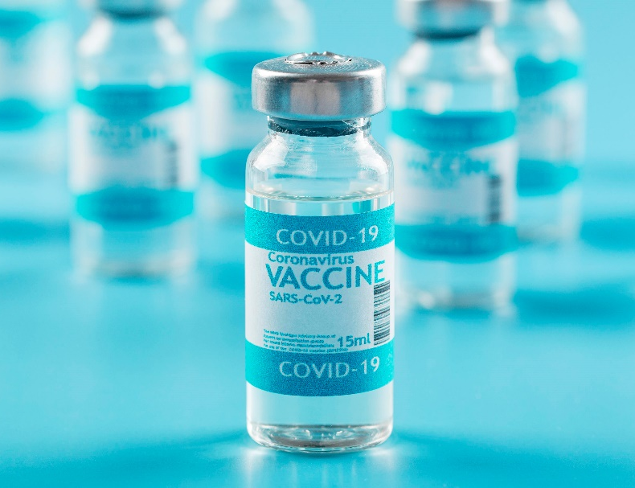

Engaging private companies to deliver vaccines
Many countries deliver vaccines in collaboration with private health service providers and pharmacies that have capacity to vaccinate. They may allow private entities to provide vaccines at their sites, or contract with providers to staff a public vaccination site.
A variation of this model is to work with large companies that have a significant workforce to let them vaccinate their employees through the company’s occupational medicine team or a contracted-in private provider, reducing the burden on the local health care services. Mining or agriculture companies with a large rural footprint could possibly organize the vaccination of entire rural communities in areas where they are the dominant employer—many already run local clinics for their staff and families. There are different scenarios for public-private interface and the sharing of responsibility, as shown below:
 | Public financing, private delivery | Private financing, public delivery | Private financing and delivery
Sourcing | Public | Public or private | Public or private
Indemnification/ Compensation | National solution | National solution | National solution
Price | Free for citizens | Free for citizens | Free or for fee, regulated or unregulated
Prioritization | Public guidelines | Public guidelines or special agreement | Public guidelines or other solution
Certificate, registry | National solution | National solution | National solution
AEFI¹ reporting | National solution | National solution | National solution
TRack & Trace | National solution | National solution | National solution or private solution

This table is not exhaustive—other scenarios or choices may make sense depending on the local context—but it offers some suggestions on how different issues can be addressed. The first scenario, public financing and private delivery, is a more common one in which the public sector procures vaccines and gives them to a private hospital, clinic, or pharmacy, which acts as a vaccination center for the general population. This service should be free for citizens; the government can require that all rules and guidelines regarding prioritization, vaccine certificates, reporting into a central database, and reporting of side effects (Adverse Events Following Immunization [AEFI]) are followed. The use of the vaccines would fall under the indemnification clause and the standardized compensation mechanism for potential injuries governments are asked to sign before manufacturers deliver vaccines to the country.
The second scenario speaks to a less common situation in which private businesses buy vaccines and ask government health services to deliver them. This could arise as an altruistic contribution by a private business to accelerate vaccination of the entire population. In this case the rules from Scenario 1 would apply—the vaccines would be used in the same way as those procured by the government for public use. A similar model has been chosen in Ghana—private companies buy vaccines for their own employees and make a 1:1 matching donation to the government for the general campaign. The sourcing of vaccines in this model could be through a government contract or as separate from the open market. In the latter case, there is a risk of buying fake products (see section on risk management). A private business could also buy vaccines and give them to a public facility specifically to vaccinate the employees of the company and their families. A mining company may choose to finance the vaccination of an entire village to reduce regional transmission and ensure the safety of workers and their families. In such cases, general public prioritization guidelines could be replaced by specifically negotiated rules for prioritization of certain populations.
The third scenario is entirely private, although the private buyer could potentially use the government sourcing mechanism to access cheaper vaccines. If legally possible, this approach would be preferrable as it gives the government leverage to ensure that the private provider follows public guidelines for issuing vaccine certificates, reporting vaccinations and side effects into a central database, and keeping vaccinations free or capping out-of-pocket costs at an agreed level. Examples for this scenario would be health care providers (for example, hospital chains or social franchising networks) buying vaccines and offering them to the population for a fee, or large companies buying vaccines to immunize their workforce and their families through their occupational health service team.
The underlying assumption for these scenarios is that there is no longer a vaccine shortage in the global market; the bottleneck is now purchasing power or capacity to deliver vaccines. As long as governments can access only very limited supplies from the COVAX facility, the public sector will have priority and only the first scenario (contracting with a private provider for delivery) is relevant.

Principles for managing private partners in the COVID-19 vaccine rollout
Partnerships with private companies should be based on written contracts. In many countries there is a legal framework for public-private collaboration. The World Health Organization (WHO) issued a general guideline for engaging the private sector in the COVID-19 response², including the following key recommendations³:
- Set up a coordination mechanism with access to relevant information and ensure regular communication with private sector partners.
- Conduct a rapid scoping exercise to identify private sector resources that could be used to support the vaccine rollout; assess gaps and funding needs.
- Define roles, responsibilities, and division of labor.
- Identify legal and regulatory obstacles that can be addressed/waived, for example, through emergency orders.
- Develop a standard contracting template for private sector engagement.
- Develop guidelines and procedures for all steps of the vaccination campaign and share with private sector partners.
- Ensure availability of supplies needed by private partners to fulfill their role (personal protective equipment [PPE], syringes, needles, waste management, and so forth—for all items that cannot be easily purchased on the local market).
- Ensure that the entire workforce, public and private, has access to daily updates on information relevant for their role as frontline ambassadors of the national campaign.
- If possible, work with one centralized system for procurement, distribution, regulatory clearance and oversight, reporting of adverse effects, issuing vaccination cards, and collecting vaccination data.

This list is meant to support a rapid response with mobilization of private sector resources. It may need to be amended or adapted based on the local situation.

Risk management in public-private collaboration
In a pandemic, the speed of the response is critical for containing the spread of disease and to reduce mortality. Decisions must be made and implemented quickly, which means that errors and mistakes are inevitable. This might require collaboration with new partners—with whom there is no preexisting relationship of trust—which could cause friction. Countries have been more or less successful in managing this turbulent phase of “building the airplane while flying” through a central coordination mechanism that interacts will all stakeholders and maintains regular two-way communication.
A major external risk in a situation of vaccine shortage is the presence of fake vaccines. Fake and substandard drugs and vaccines are an unresolved challenge in many countries that have leaky borders and weak regulation and enforcement. The pandemic creates a huge illegal business opportunity for criminal networks.
At global level, a verification system for COVID-19 vaccines is in preparation and should be accessible to interested countries before the end of 2021. This system would allow verification of a shipment of vaccines by scanning a barcode and uploading it through a smartphone app into a central global database.

AEFI = Adverse Events Following Immunization
² https://www.who.int/publications/m/item/an-action-plan-to-engage-the-private-health-service-delivery-sector-in-the-response-to-covid-19
³ Adapted from the long list in the original document

The Health, Nutrition and Population Knowledge Briefs of the World Bank are a quick reference on the essentials of specific HNP-related topics summarizing new findings and information. These may highlight an issue and key interventions proven to be effective in improving health, or disseminate new findings and lessons learned from the regions. For more information on this topic, go to: www.worldbank.org/health.

Manufacturers upload serialization data from their manufacturing lines into this database, so, for instance, a vaccine package received by a health worker in a village clinic can be instantly authenticated. If the authentication fails, the vaccine is probably a fake.
Other than this verification system, countries can reduce the risk of fake vaccines by centralizing their procurement and buying from official channels such as COVAX, or directly from major manufacturers that have a marketing license or emergency use authorization in the country. Every intermediary (importer, wholesaler) increases the risk that fake products can be smuggled into the supply chain. Limiting the number of such “middlemen” is therefore the way to reduce the risk. Some countries have national tracking systems for medicines and vaccines; many have not. For the latter tranche of countries, the solution could be to contract with a major distributor who handles the entire supply chain from import (shipped by the manufacturer) to delivery to the site where vaccines are used. This distributor may have a tracking system that can feed a dashboard at the control center, giving regulators and the public officials in charge full visibility of the supply situation for the entire country.
Another essential element of risk reduction could be a ban on all unauthorized sales of COVID-19 vaccines outside the official channels controlled by the government and its contractors. The population should be informed about the places authorized for vaccines and warned that all offers of nonauthorized providers should be avoided and reported to a central hotline that is set up with the responsible regulatory authority.

